1. Mission Statement

Albemarle County’s stated mission is to enhance the well-being and quality of life for all citizens through the provision of the highest level of public service consistent with the prudent use of public funds.

1. Mission background and language (well-being +quality of life)

Well-being - a core part of the County’s mission – is a multi-faceted concept which includes global positive emotions and resilience, the realization of one’s potential, and “overall satisfaction” with one’s life and one’s community.[1] Further, many studies have shown us that health and wellbeing are affected not just by individual behaviors, but also by environmental, social, and economic factors.[2] In order to achieve the County’s stated mission, our policies must ensure that well-being is distributed equitably within the various populations that make up our diverse community. Equity means that all community members have access to community conditions and opportunities needed to reach their full potential and to experience optimal well-being and quality of life.

1. Chapter 1 What and why is this document
   1. OEI Background
      1. Relationship between mission statement and RDEI
2. Chapter 2-Framework
   1. HDI Framework
      1. Explain/define AHDI (use their graphic)(credit Measure of America)

The American Human Development Index is a metric that assesses the distribution of well-being and equity along three axes: health, access to knowledge, and living standards. As an alternative to money metrics like GDP (Gross Domestic Product), the HDI measures basic indicators of human well-being, going beyond simply measuring income or economic growth. The first HDI was presented in 1990, and it is now used around the globe to gauge quality of life. Governments in many countries use the HDI as an official statistic, employing this data to launch conversations about how to promote policies that will enhance equity for all people.   
 In addition to illuminating facets of well-being that cannot be measured through money metrics, the HDI is a cross-cutting index that reflects the interconnectedness of many different sectors: health, education, housing, and more. Human wellbeing is influenced by a multiplicity of factors that cannot be isolated from one another, and the HDI captures many of these factors at once. Further, instead of simply offering more data on ongoing problems (i.e., poverty, health issues), the HDI focuses on measuring the *impact* of ongoing efforts to resolve these problems.

By looking at the full spectrum of people in our community, the HDI also promotes an inclusive view in which all of us can see ourselves. This unique approach moves away from prior methods that focus solely on those living in poverty, which sometimes reinforce an us-and-them outlook.

* 1. HDI & Albemarle Overview
     1. HDI comparison (Albemarle, VA, US)

Benchmark localities are from the board of supervisors.

This come from: Measure for America & the health department [maybe]

Aim: Get most current of each measure that we can.

Maybe get 2016-2018 life expectancy measures from county health rankings

Consider racially disaggregating the AHDI

Start each section with the AHDI component and maybe some summary numbers for that component.

|  |  |  |  |  |  |  |  |  |
| --- | --- | --- | --- | --- | --- | --- | --- | --- |
|  | AHDI | Life Expectancy at Birth | Less Than High School (% of adults 25+) | At Least High School Diploma (% of adults 25+) | At Least Bachelor’s Degree (%of adults 25+) | Graduate or Professional Degree (% of adults 25+) | School Enrollment (% ages 3 to 24) | Median Earnings |
| US | 5.43 | 78.6 | 12.3 | 87.7 | 31.5 | 12.1 | 77.3 | 33,439 |
| Virginia | 6.39 | 79.5 | 10.7 | 89.3 | 38.2 | 16.4 | 77.2 | 44,378 |
| **Albemarle** | **7.28** | **81.2** | **8.6** | **91.4** | **53.5** | **26.1** | **82.6** | **45,865** |
| Rockingham | 5.72 | 80.7 | 16.5 | 83.5 | 25.9 | 10.5 | 75.8 | 36,720 |
| Augusta | 5.59 | 80.7 | 12.6 | 87.4 | 23.5 | 8.4 | 71.2 | 37,110 |
| Harrisonburg | 5.84 | 79.8 | 15.9 | 84.1 | 36.0 | 15.5 | 87.1 | 31,568 |
| Charlottesville | 6.92 | 79.8 | 9.1 | 90.9 | 52.6 | 27.2 | 85.4 | 41,295 |
| Fairfax | 8.62 | 85.1 | 7.9 | 92.1 | 61.1 | 30.2 | 82.4 | 60,126 |
| Stafford | 7.13 | 80.3 | 6.3 | 93.7 | 39.8 | 16.6 | 75.6 | 57,312 |

* + 1. VA Benchmark localities

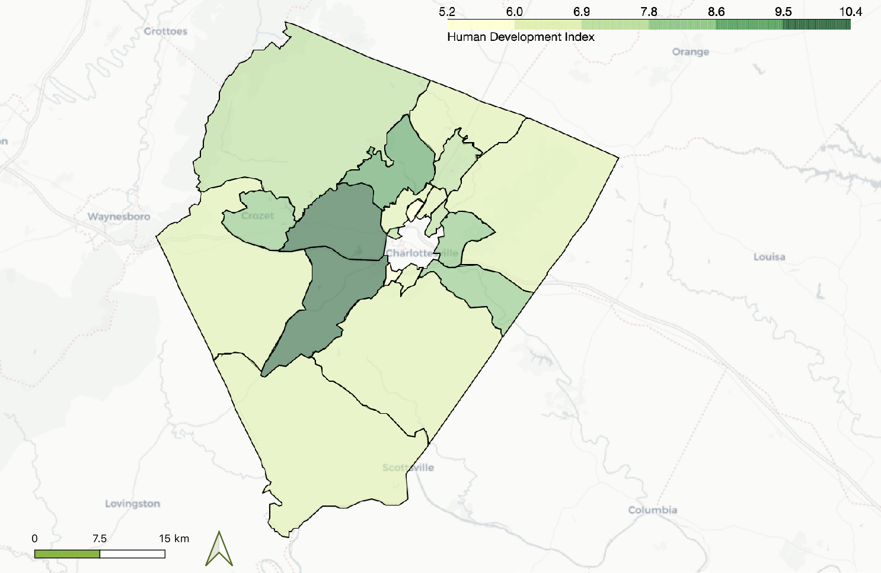

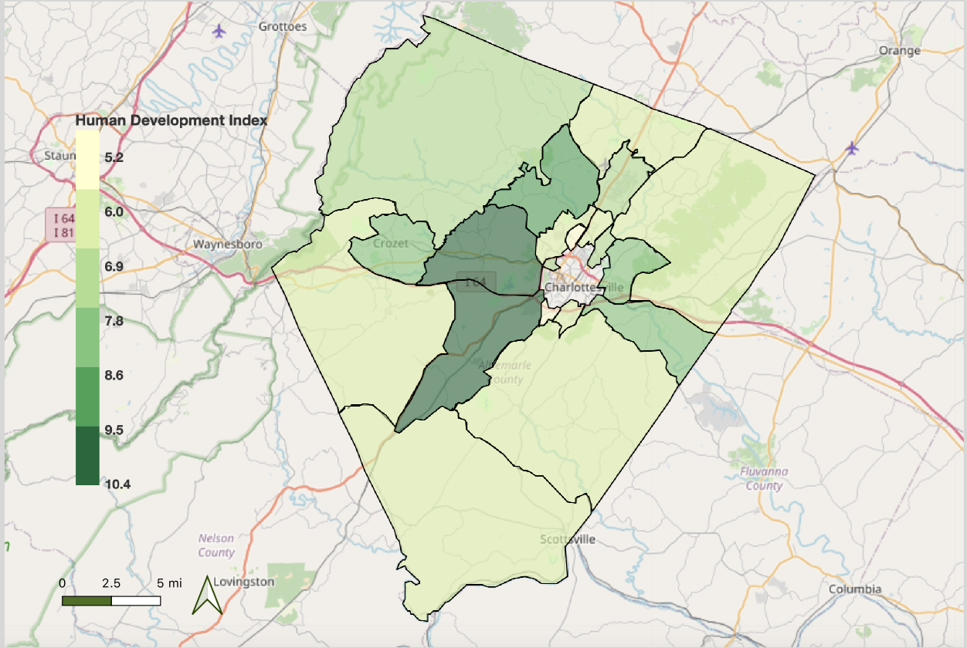

1. Chapter 3 -A closer look
   1. Albemarle Demographics
      1. Race

Albemarle County’s population has witnessed significant demographic shifts over time, and changing demographics indicate fluctuating conditions of equity for particular populations. Prior to European settlement, Native Americans - primarily Monacan people - inhabited the area. African-Americans (free and enslaved) then constituted the majority of Albemarle’s population prior to the American Civil War and directly afterward. Freedmen and women established separate rural communities throughout the County, such as Proffitt. However, with the advent of the railroad, and continuing inequity wrought by white landowners, and a Jim Crow-era segregationist government, many African-Americans people in Albemarle County were forced to migrate out of Albemarle County began migrating and move northward during the era of in the Great Migration.

Since then, Even though Albemarle’s population has been majority white .Since roughly the Jim Crow era, However, during the last two decades, the County has been growing more diverse over the last two decades. As of 2018, nNearly a quarter of Albemarle’s community members are people of color, as of 2018. African-American people constitute the largest minority group, comprising 42.06% of the nonwhite population. LatinxHispanic and Asian minorities also constitute a significant portion of the non-white population. The population has also aged significantly in the last [timeframe].

A demographically-changing population often means that there will be new perspectives, new strengths, but also new needs within the population that have to be met. As local government, it is critical for us to be sensitive to the changing needs of our community and alter our services accordingly in order to promote the well-being for all residents throughout the County.and circumstances for local government to respond in Albemarle County. Being sensitive to these community needs is critical to promoting greater equity. Further, when the local government responds to the needs of minorities, *everyone* lives better - not just a few.

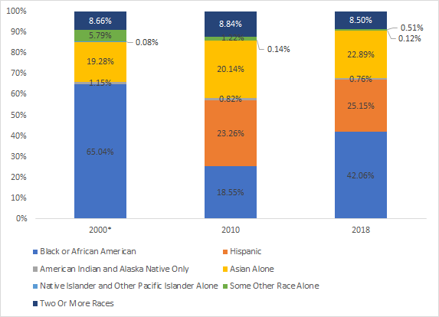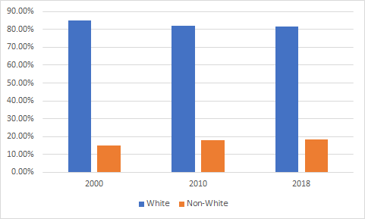

* + 1. Place

Race vs. Ethnicity in the charting practices. Do two different ones.

There is an interest in showing how it has changed over time but also its current state.

Long journey racially. When did we become a majority white community?

Do the one year estimates with the decennial census at the ten year points to interpolate

Do we want to go prior to 2000? For the white/non-white graph but maybe not the full breakdown

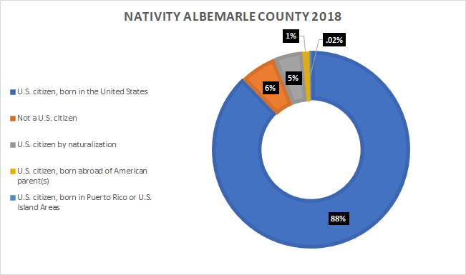

Do this for 2019

“New American” Language.

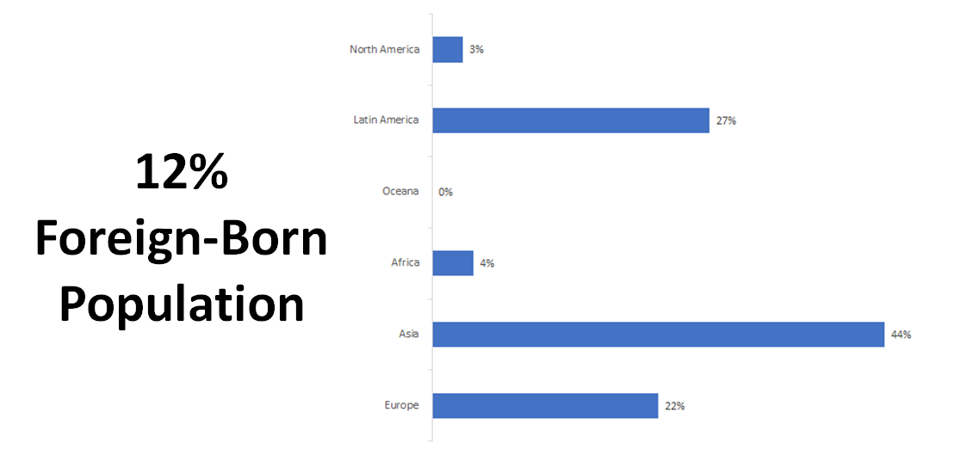

* + 1. Age

Age is another crucial factor to consider when making decisions that will enhance the overall equity of our community. As in much of the United States, Planning District 10’s senior population has been increasing steadily, and is projected to reach 19.4% of the population by 2023.[3] As the data show, the number of people in our area who are over age 60 has been rising significantly since 2010. For this reason, it is all the more important to make Albemarle an age-friendly community: a community that is livable for all ages, where people can age in place. Further, many policies that make communities more age-friendly also benefit us all: making neighborhoods more walkable, enhancing transportation options, promoting inclusivity, and ensuring affordable housing are things that benefit not just seniors but the entire population. Ensuring equity for the most vulnerable means we all live better.

Age-friendly communities adapt their infrastructure and social services to respond to the needs of older people with varying abilities. Studies of age-friendly communities often use a framework that includes eight domains of livability, which includes outdoor spaces and buildings, transportation, housing, social participation, respect and social inclusion, work and civic engagement, communication and information, and community and health services.[4] Our County government has a key role to play in each of these domains, by ensuring that all of our public services cater to a diverse range of ages.

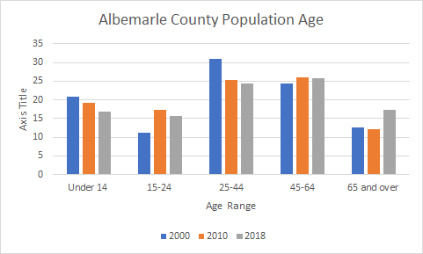

2000 – 2019.

What age breakdowns to use?

* + 1. Gender

As of the 2018 American Community Survey, the Albemarle County population was 48% male and 52% female.

1. Chapter 4- A Long & Healthy Life (with image)
   1. Indicators being covered
   2. life expectancy/social determinants of health?

According to the Thomas Jefferson MAPP2Health, life expectancy refers to a “key population health measure used to gauge health and longevity” (142). Life expectancy at birth generally refers to the number of years a given population is expected to live, based on statistical projections. Research has shown that financial, socioeconomic, and environmental factors can have an effect on life expectancy, as can access to healthcare. Individual behavior and physiology also play into life expectancy, but, as the Thomas Jefferson MAPP2Health makes clear, “where we live, work, play and pray (social determinants of health) have an equally important impact on our health and well-being” (2). The CDC estimates that as much as 50% of individual health is due to “social, economic, and environmental factors, such as racism, discrimination, education, and housing” (TJHD MAPP2Health, 2).

While life expectancy in general has increased over the 20th century, not all populations are experiencing this trend equally. Albemarle County has the highest overall life expectancy in the TJHD region (84.4 years), but significant racial disparities in life expectancy still exist in our County. The MAPP2Health estimates that from 2008-2012 the TJHD region’s non-Hispanic white population had a life expectancy of 81.2 years. By contrast, the estimated life expectancy for the TJHD’s region’s Black population was 74.7 years of age.

When we look at the data, we can also see that life expectancy breaks down by census tract in our County. Not every tract in our County experiences a similarly high level of life expectancy.

* + 1. Census tracts-highlighting high/low

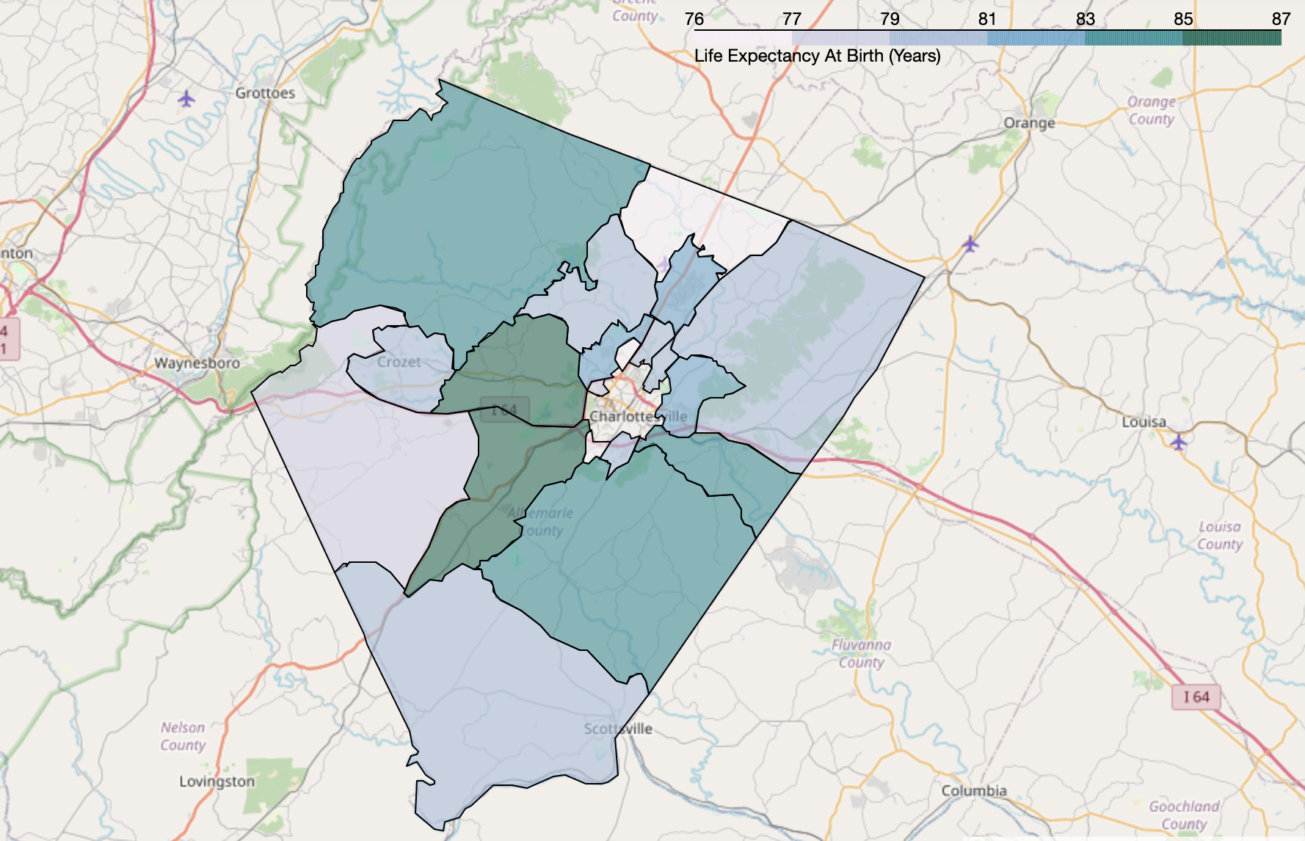

We want to make sure everything is coming from the same place. Detailed sourcing notes for each of our charts. Aim to use the newest county health rankings. Do we need to map it?

Colloquial names that people might know for the census tracts?

* 1. Food security
     1. Opportunity for greater investment

Food is vital to wellbeing, and yet food insecurity rates have not declined in the U.S. in two decades (USDA, “Food Security in the US”). Food is a key equity issue, since a community cannot reach its full potential if some of its members are going hungry or lacking access to affordable and nutritious food. When we look at the statistics, we see that hunger and food insecurity are experienced unequally: on the whole, low-income communities and people of color are more likely to experience food insecurity; further, children and seniors are more vulnerable to the health and developmental setbacks that come with insufficient or nutrient-deficient food.3 Achieving food equity thus means ensuring equitable access to fresh, nutritious, and affordable food for *all* peoplein our community, regardless of race, gender, age, income level, or nationality.

While Albemarle County’s rate of food insecurity is relatively low, it does not seem to be declining, and data suggests that it will rise in the coming years due to the COVID-19 pandemic and subsequent job loss.

1. Chapter 5 Access to Knowledge
   1. Why educational attainment

Within the HDI framework, access to knowledge is measured using two indicators: school enrollment (for those who are 3-24 years old) and degree attainment (for those over 25). Education is intertwined with many other facets of life, directly influencing employment and earnings, and indirectly influencing access to decent housing, food, healthcare, and transportation. The monetary benefits of educational attainment are clear: those with a bachelor’s degree make, on average, about double what high school graduates earn (*NYC Measure of America,* 125). Moreover, educational attainment can have positive social outcomes for the entire population: lower incarceration rates, lower crime rates, greater civic engagement, as well as longer and healthier lives, have all been linked to making education more accessible (*NYC Measure of America,* 125).

* 1. Race/gender (needs context +considerations)

|  |  |  |  |  |
| --- | --- | --- | --- | --- |
|  | **Less Than High School (% of adults 25+)** | **At Least High School Diploma (% of adults 25+)** | **At Least Bachelor’s Degree (%of adults 25+)** | **Graduate or Professional Degree (% of adults 25+)** |
| **United States** | **12.3** | **87.7** | **31.5** | **12.1** |
| **Virginia** | **10.7** | **89.3** | **38.2** | **16.4** |
| Men | 11.5 | 88.5 | 38 | 17.1 |
| Women | 9.9 | 90.1 | 38.3 | 15.9 |
| Asian | 10.3 | 89.7 | 60.2 | 27.9 |
| White | 9 | 91 | 40.6 | 17.5 |
| Black | 14.5 | 85.5 | 23.6 | 9.7 |
| Latino | 28.5 | 71.5 | 24.4 | 9.5 |
| Asian Women | 12.2 | 87.8 | 56.6 | 24.2 |
| Asian Men | 7.9 | 92.1 | 64.4 | 32.3 |
| White Men | 9.9 | 90.1 | 40.8 | 18.2 |
| White Women | 8.2 | 91.8 | 40.4 | 16.7 |
| Black Women | 13.4 | 86.6 | 25.8 | 10.9 |
| Latina Women | 26.4 | 73.6 | 26.2 | 9.2 |
| Latina Men | 30.5 | 69.5 | 22.8 | 9.7 |
| Black Men | 15.6 | 84.4 | 21.1 | 8.3 |

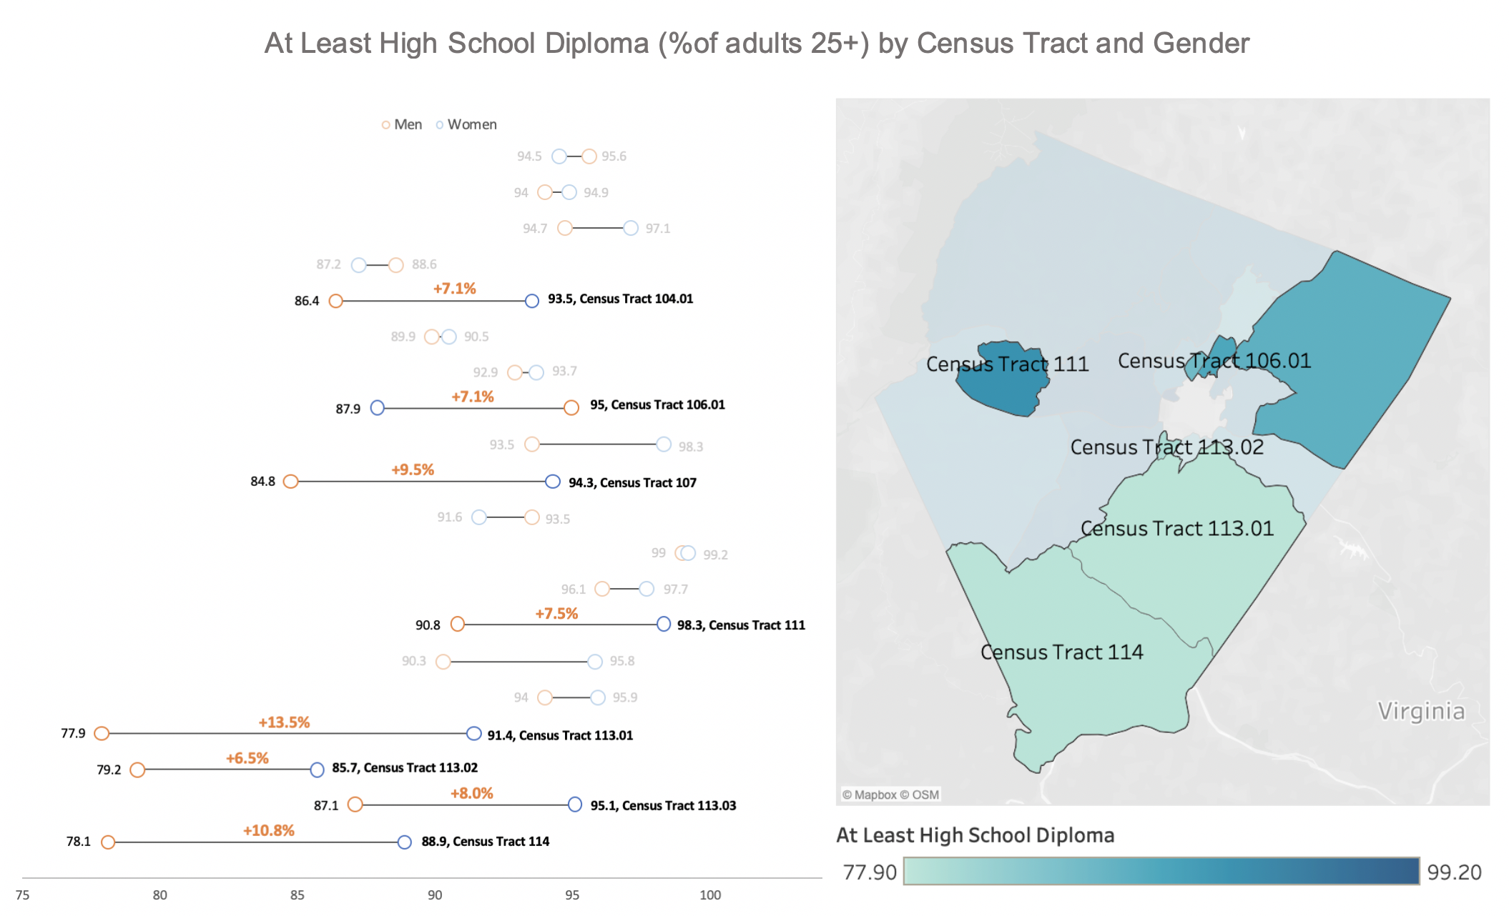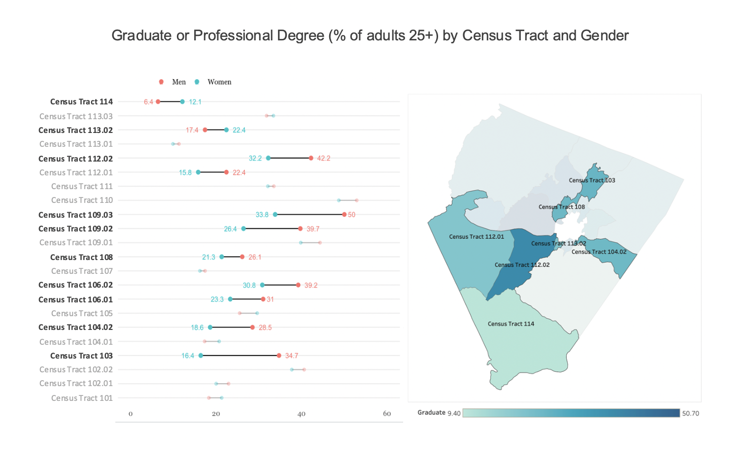

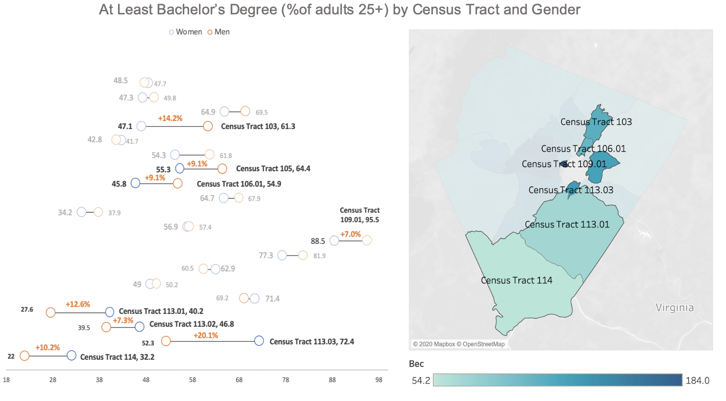

1. Chapter 6 Decent Standard of Living
   1. Why income vs wealth?
   2. Median income
      1. Albemarle, VA, US

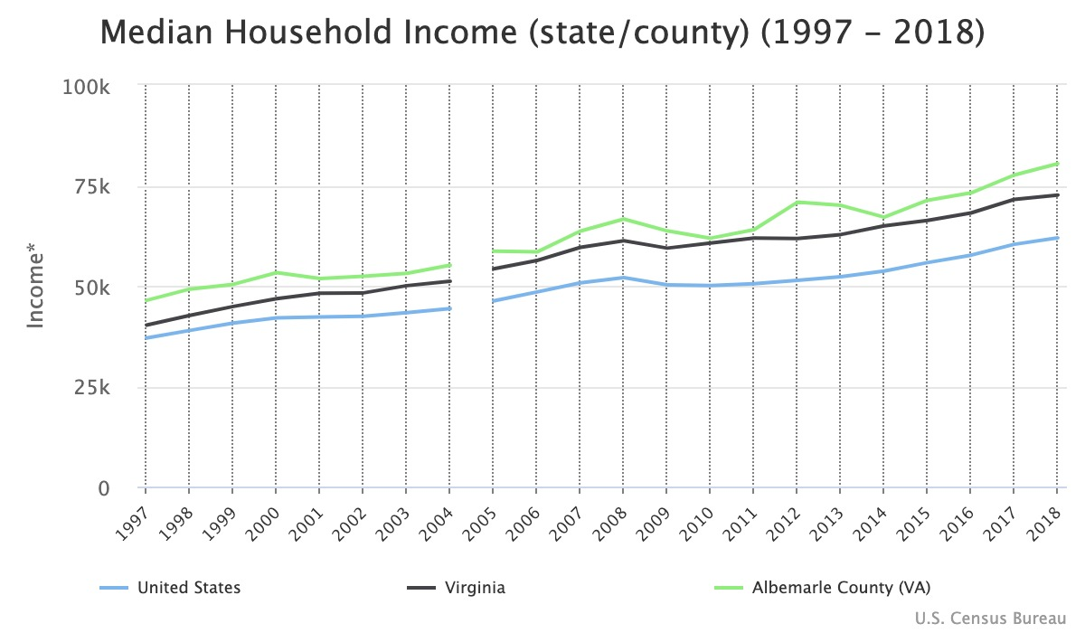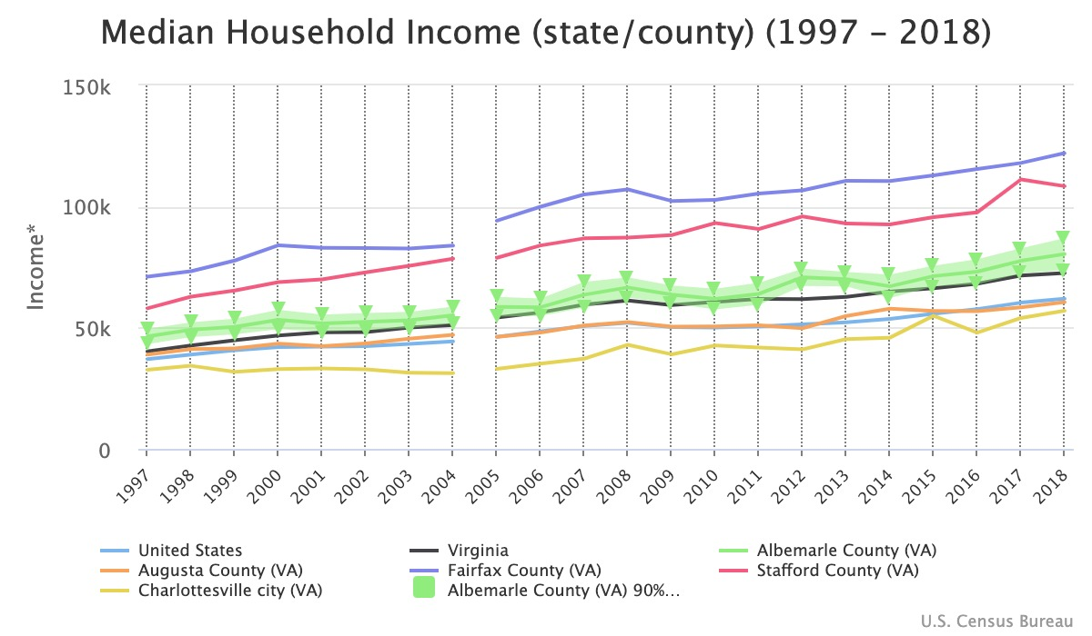

Median Household Income(1989-2018) Source: [link](https://www.census.gov/data-tools/demo/saipe/#/?map_geoSelector=mhi_s&map_yearSelector=2018&s_year=2018,2009&s_state=51&s_county=51003&s_measures=mhi_snc)

|  |  |  |  |
| --- | --- | --- | --- |
|  | Albemarle | Virginia | United States |
| 2018 | $80,392 | $72,600 | $61,937 |
| 2017 | $77,591 | $71,518 | $60,336 |
| 2016 | $73,132 | $68,127 | $57,617 |
| 2015 | $71,293 | $66,263 | $55,775 |
| 2014 | $67,083 | $64,923 | $53,657 |
| 2013 | $70,032 | $62,745 | $52,250 |
| 2012 | $70,813 | $61,782 | $51,371 |
| 2011 | $63,972 | $61,877 | $50,502 |
| 2010 | $61,845 | $60,665 | $50,046 |
| 2009 | $63,669 | $59,372 | $50,221 |
| 2008 | $66,606 | $61,210 | $52,029 |
| 2007 | $63,619 | $59,575 | $50,740 |
| 2006 | $58,428 | $56,297 | $48,451 |
| 2005 | $58,620 | $54,207 | $46,242 |
| 2004 | $55,118 | $51,103 | $44,334 |
| 2003 | $53,104 | $50,028 | $43,318 |
| 2002 | $52,365 | $48,224 | $42,409 |
| 2001 | $51,783 | $48,130 | $42,228 |
| 2000 | $53,263 | $46,789 | $41,990 |
| 1999 | $50,362 | $44,848 | $40,696 |
| 1998 | $49,171 | $42,622 | $38,885 |
| 1997 | $46,371 | $40,209 | $37,005 |
| 1996 | NA | $38,510 | $35,492 |
| 1995 | $43,475 | $36,367 | $34,076 |
| 1993 | $41,542 | $34,818 | $31,241 |
| 1989 | NA | $32,555 | $28,906 |

* 1. Income inequality

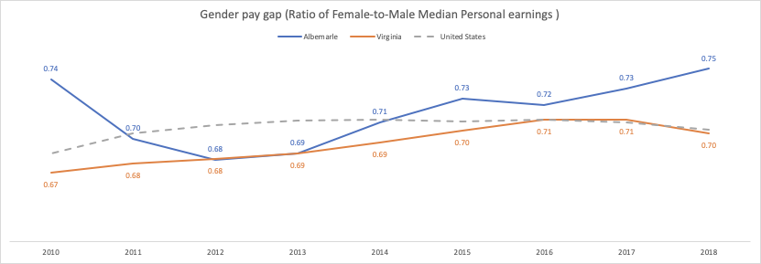

* 1. Cost of living
     1. UW ALICE Framework

1. Summary Points

1. Centers for Disease Control and Prevention, “Well-Being Concepts”; Sirgy et al., “Developing a Measure of Community Well-Being Based on Perceptions of Impact in Various Life Domains.”
2. Healthy People 2020, *Social Determinants of health.* 
3. Partners for Economic Solutions, *Comprehensive Regional Housing Study and Needs Assessment* (2019), p. 6.
4. AARP, “The 8 Domains of Livability: An Introduction,” <https://www.aarp.org/livable-communities/network-age-friendly-communities/info-2016/8-domains-of-livability-introduction.html>. World Health Organization, *Global Age-Friendly Cities: A Guide.* (2007).